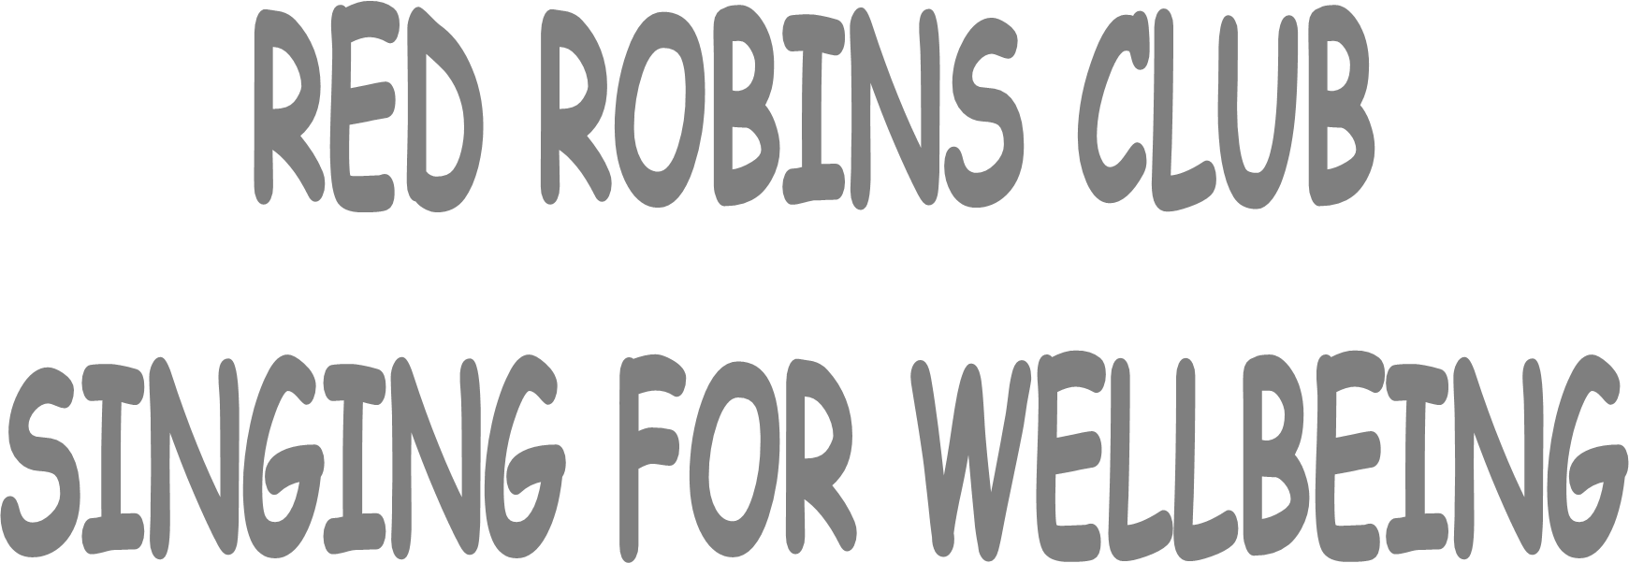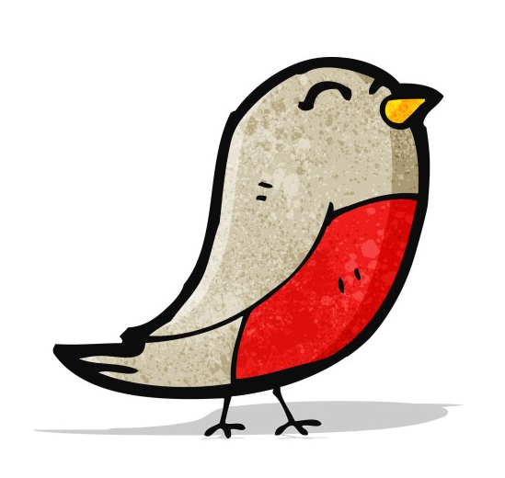
Singing is clinically
proven to improve your
wellbeing so why not
come along and join in
the fun?

Founded in 2016 to help people living with Parkinson’s, Stroke, MS and depression by singing and music making. Pop in for a session of fun, light-hearted songs and singing exercises followed by chat and refreshments.
EVERY THURSDAY 11:00am - 12:30pm

EMMANUEL CHURCH HALL
HADLOW ROAD
SIDCUP
DA14 4DR
£4pp, carers £2
www.redrobinsclub.com  07900 205 862

