CHRISTMAS CAROL SERVICE in British Sign Language

Christchurch, Bexleyheath (next to Asda)
Bexley Deaf Centre will be joined by the children of Pelham School
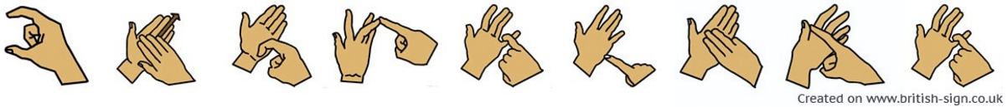
Thursday 6th December
at 6.30pm
All welcome

