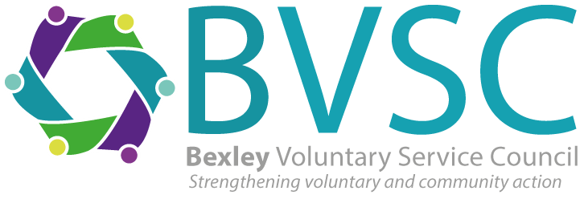

BEXLEY VOLUNTARY SERVICE COUNCIL

Office and Data Lead for Pathways (full time)

Salary £38,571 inc OLW

Due to an internal promotion, BVSC are seeking an Office & Data Lead, supporting the One Bexley Consortium to improve care and support services for local residents. In this key role, you’ll manage referral pathways, oversee data analysis and ensure seamless communication between consortium partners and the Local Authority. If you are a proactive, data-driven individual with a passion for supporting the community, we’d love to hear from you!

Closing date for applications is 5pm 25th February 2025.
Interviews are likely to be held on Monday 3rd March 2025
Completed applications should be returned via e-mail to info@bvsc.co.uk

Don’t meet every single requirement? At BVSC we are dedicated to building a diverse, inclusive and authentic workplace, so if you’re excited about this role but your past experience doesn’t align perfectly with every qualification in the job description, we encourage you to apply anyway. You may be just the right candidate!

BVSC, Engine House, 2 Veridion Way, Erith DA18 4AL
Tel: 01322 524682.

Charity No. 279880
Company Limited by Guarantee 1501746

