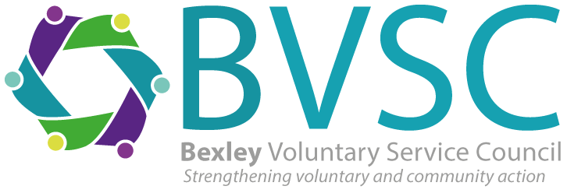

Applying for the post of Community Wellbeing Co-Ordinator (Social Prescribing Link Worker):

Please read the job description and person specification and answer the following 4 questions in no more than 5000 words per question.

- What qualities and skills can you bring to this role at BVSC?

- Please describe your experience providing support to residents, with reference to the person specification. Please give examples of work you have done.

- Please outline your experience of working with people from diverse backgrounds and how you engage with different audiences.

- This post can be busy with competing priorities and deadlines. Tell us how you would manage working in an often fast paced environment

When you have completed the questions, please ensure you include an up to date CV with the application. We will not consider applications without all 4 questions completed and a current CV.

Please return your CV and completed questions to info@bvsc.co.uk by 9am on Thursday 18th July 2024. If you have not heard from us by 19th July, please assume your application was not successful, we are unable to provide feedback on applications which are not shortlisted. We expect interviews to take place on Thursday 25th July.
.

